Article for TERN website and August eNewsletter

3-Word Title for Newsletter: Soil moisture data

Title for website & newsletter: Accurate, near real time, daily volumetric soil moisture information, Australia-wide
Teaser: TERN’s new world-leading soil moisture information system provides nation-wide daily estimates of volumetric soil moisture at a 1km resolution and an index of how full (or wet) the top 90cm of soil is at a particular location and time. The system will help land managers better monitor drought, predict bushfires and floods and make highly informed management choices to improve agricultural productivity.

Understanding soil moisture matters. Accurate soil moisture data can improve weather forecasts, help monitor droughts, predict bushfires and floods, improve agricultural productivity, and enable more accurate budgeting of water, energy and carbon. Soil moisture is also a critical driver in ecological function and environmental condition.

Recognising this, TERN has been working with its infrastructure partners for more than a decade on the production, refinement and provision of national-scale soil moisture data. We’re now pleased to announce the launch of the Soil Moisture Integration and Prediction System (SMIPS).

SMIPS provides nation-wide daily estimates of volumetric soil moisture at a resolution of approximately 1km. It also provides an index of between 0-1 which approximates how full (or moist) the top 90cm of soil is at a particular location and time.

INSERT Comment from Ben MacDonald

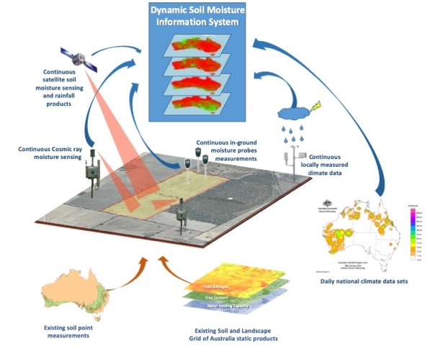
TERN’s new Soil Moisture Integration and Prediction System (SMIPS) will incorporate existing data from TERN’s Soil and Landscape Grid of Australia, remotely-sensed rainfall data and Bureau of Meteorology (BoM) climate data with soil moisture data collected by on-ground monitoring equipment at TERN and partner sites around Australia

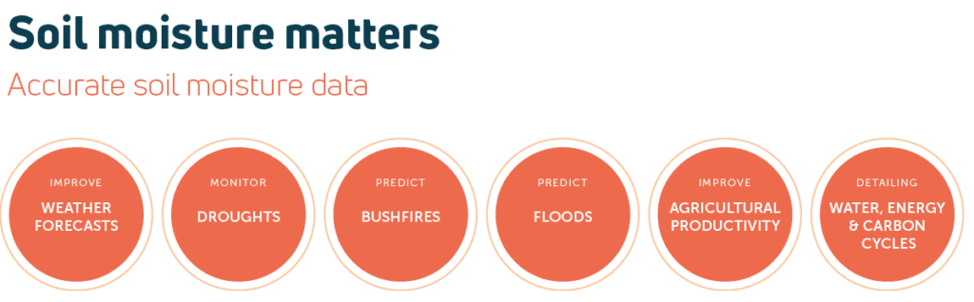
Accurate soil moisture data can improve weather forecasts, help monitor droughts, predict bushfires and floods, improve agricultural productivity, and enable more accurate budgeting of water, energy and carbon. Soil moisture is also a critical driver in ecological function and environmental condition.

World-leading data system fills essential infrastructure gap
The SMIPS system was developed thanks to investments by TERN, CSIRO, the Australian National University (ANU), the Bureau of Meterology (BoM), the Grains Research and Development Corporation (GRDC), the University of Sydney and the University of Southern Queensland.

SMIPS incorporates data from TERN’s Soil and Landscape Grid of Australia, precipitation and potential evapotranspiration data from the Bureau of Meteorology’s AWRA Model, and soil moisture data collected by on-ground soil moisture monitoring equipment (including COSMOS sensors) at TERN and partner sites around Australia.

To increase accuracy its links in continuous (daily) satellite soil moisture data from the European Space Agency’s Soil Moisture Ocean Salinity (SMOS) Earth Explorer mission.

In addition to version 1.0 of the model, an experimental version of the model is available for user testing. This version of the model uses precipitation data supplied by an experimental CSIRO daily rainfall surface generated using spatial data from the NASA Global Precipitation Mission as a base and enhanced using rainfall observations from the Bureau of Meteorology (BoM) rainfall gauge network, and various landscape covariates, processed using a machine learning approach.

“Traditionally, soil moisture is measured using on-the-ground point-based sensors and while these data are useful at a paddock scale, the ability to interpolate to larger areas is limited.

At the other end of the scale, modelling is used to upscale on-ground point measurements and estimate soil moisture over large areas. But, modelling is often unable to adequately capture and represent all of the physical processes involved, and the spatial resolution of new global-scale satellite products resolution is far too coarse for management decisions, and importantly, fails to capture important local processes.

The SMIPS soil moisture system developed through TERN, takes a data model fusion path to produce daily estimates of volumetric soil moisture by combining the local physical representation of modelling with the spatial coverage of national digital soil information and the temporal consistency of satellite-based products, to produce a ‘best-of-both-worlds’ continental scale soil moisture product.

This revolutionary project is changing the way we estimate soil moisture and Australia’s national research infrastructure makes this possible. Accurate, real time data availability fills an essential national data gap.”

Matt Stenson, CSIRO

Call to action bullet points with hyperlinks
- Access SMIPS here:
  - Simple Data Portal: https://shiny.esoil.io/SMIPS/
  - Cloud Optimised GeoTIFFs (COGs): https://data.tern.org.au/landscapes/smips
Access the data via TERN’s Data Discovery Portal:
Insert Matt’s TERN Science Symposium presentation: https://vimeo.com/575211774

Publishing details
Approvals | Matt Stenson – CSIRO  Ben McDonald - CSIRO  Ross Searle – CSIRO  Brendan Malone - CSIRO  Mark Grant (author) – TERN  Beryl Morris – TERN
Call to action at end of article | - Access SMIPS here:  - Simple Data Portal: https://shiny.esoil.io/SMIPS/  - Cloud Optimised GeoTIFFs (COGs): https://data.tern.org.au/landscapes/smips  Access the data via TERN’s Data Discovery Portal:
Image suggestions | As above
Image caption | As above
Image alt text | TBA
TERN newsletter teaser | TERN’s new world-leading soil moisture information system provides nation-wide daily estimates of volumetric soil moisture at a 1km resolution and an index of how full (or wet) the top 90cm of soil is at a particular location and time. The system will help land managers better monitor drought, predict bushfires and floods and make highly informed management choices to improve agricultural productivity.
Article meta description for website | TBA
Article link | TBA
Social media posts
Twitter post #1 | TBC
Twitter post #2 | TBC
Twitter handles & hashtags to include | @CSIRO,
LinkedIn & Facebook post #1
LinkedIn Organisations to tag

